LOCATION : NATIONWIDE
DATE : 12.05.2017
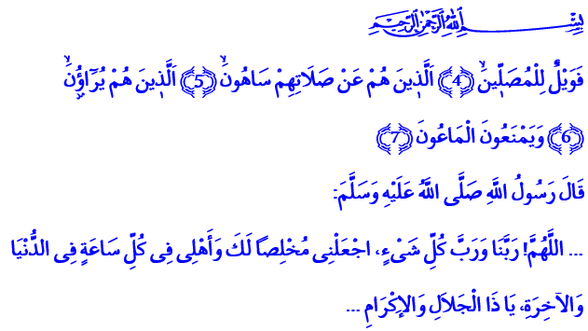EPITOME OF INSINCERITY: HYPOCRISY A Blessed Friday to You, Brothers and Sisters!
In today’s khutbah, I would like to talk about a misdeed that wipes out and sweeps away all the good deeds we have done. It is hypocrisy, which is the epitome of insincerity that destroys all things beautiful and cancels all good deeds. Hypocrisy is a disease that damages human relations and mutual trusts as well as bringing down the reputation the individual.
In a conversation with his companions, our Beloved Prophet (pbuh) pointed out to hypocrisy as follows: “The thing I fear the most about you is small shirk,” says Allah’s Messenger. They ask, “What’s a small shirk, o Allah’s Messenger?” Our Prophet answers: “Hypocrisy is the small shirk. As Allah repays everyone for their deed on the Day of Reckoning, He will tell this to hypocrites: ‘Go to those to whom you were hypocrites in earthly life! Behold! Will you see a reward or good deed near them?’”
Honorable Believers!
The essence of the Sure Religion of Islam is sincerity and genuineness. It’s to make faith, worship, and obedience exclusive only and solely to Allah, the Lord of the worlds. It’s to seek Allah’s favor alone in what we say and do. It’s to be what we seem and seem what we are.
Brothers and Sisters!
Deeds lose meaning when they are stained with hypocrisy and desire for vanity. Deeds that lack sincerity and genuineness are fancy on the outside but empty on the inside. Without sincerity, values decrease in value. Sincerity is extremely important in human relations, not only in faith and worship. It is one of the best moral virtues for a believer to be sincere and genuine when among family and relatives, in relations with neighbors and friends, in business life, and in short in every area of life. The only way to attain that virtue is to aspire Allah’s favor in everything we do.
Brothers and Sisters!
If we commit hypocrisy, our prayer, which is our ascension, can’t protect us against evil. Such prayer is the type of prayer mentioned in the verse,  “Woe to those who pray!”. Such prayer is the type of prayer mentioned in the verse,  “Who are heedless of prayer.” Such prayer is the type of prayer expressly described in the verse,  “They make show of their deeds.”
Honorable Believers!
Our fasting cannot shield us against evil if we waste it for hypocrisy. If we sacrifice animals with hypocrisy, it will not get us closer to Allah. If our sadaqa, alms, and good deeds are stained with hypocrisy, they will not be able to demonstrate our obedience to Allah.
Our Prophet (pbuh) said that deeds stained with hypocrisy will lead one to great disappointment on the Day of Reckoning. If one gives alms thinking, “They will think I am generous”, his own wealth will be his fire. If one obtains knowledge thinking “They will think I am wise,” his wisdom will be his torment. In fact, if one becomes a martyr thinking, “They will think I am a hero,” his martyrdom will not be accepted. Because deeds of those who reduce their wish to pure vanity and leave Allah’s favor aside have no value by Allah.
Brothers and Sisters!
Image and vanity are dominating the world every passing day. Humanity is rapidly walking away from sincerity. Today, pretentiousness and hypocrisy are among the greatest dangers that damage our minds and spirits, threaten our faith and deeds, and hurt our human relations and friendships. As we go through a test of sincerity and genuineness in this world as believers, our duty is to veer away from two-facedness, vanity, and selfishness. Our duty is to aim for Allah’s favor, His content in everything we say and do. It’s to be wary against the hypocrites who seek to exploit our high values and sincere feelings. To never give an opportunity to those who try to sow seeds of discord, sedition, division among us by deluding us.
Honorable Brothers and Sisters!
I would like to finish my khutbah with a prayer from our Beloved Prophet: “…O Allah, Possessor of glory and honor, the Lord of everything! Make us sincere to You at every moment in this world and in the world hereafter!”

Al-Bayhaqi, Şuabü’l-îmân, V, 333.
Al-Ma’un, 107/4-6.
Muslim, İmare, 152.
Abu Dawud, Vitr, 25. Written by: General Directorate of Religious Services

